

*shell programming*

aSsignment -9

**SUBMITTED BY: SUBMITTED TO:**

**AYUSH KUMAR JHA Dr. Dhiviya Rose**

**SAP ID - 500086400**

**Enrollment no - R200220083**

**B.C.A -I.O.T.**

## **Assignment Content**

1. Create a bash script to get the command line argument with options using case block.

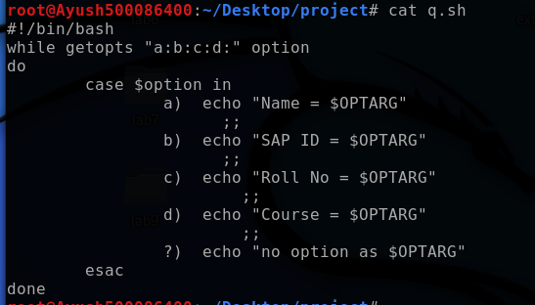

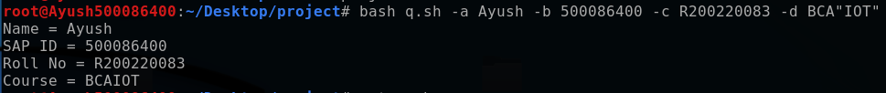

Bottom of Form